**JAVA PHENOMENON**

* **About Java Technology**
  + Java technology is both a programming language and a platform
* **The Java Programming Language**
  + Java programming language is a high level programming language
  + It can be characterized by the following buzzwords
    - Simple
    - Object Oriented
    - Distributed
    - Multithreaded
    - Dynamic
    - Architecture Neutral
    - Portable
    - High Performance
    - Robust
    - Secure
  + All source codes are written in plain text files ending with .java extension
  + Source files are then compiled into .class files by the java compiler
  + .class files contains byte codes(Machine level language)
  + Java launcher tool then runs your application with an instance of JVM

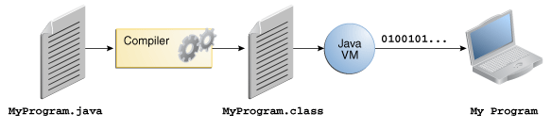

* + JVM is available on many different operating systems
  + Through JVM same application is capable of running in different operating systems
  + Some virtual machines such as Java SE HotSpot at a Glance, perform additional steps at runtime to give your application a performance boost

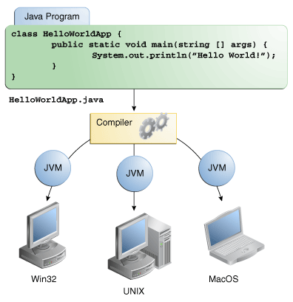

* **The Java Platform**
  + A platform is a hardware or software environment in which a programs runs.
  + Most popular platforms – Microsoft Windows, Linux, Solaris OS and Mac OS
  + Most platforms can be described as a combination of Operating system and underlying hardware.
  + The java platform is differs from others, in that its software only platform that runs on the top of other hardware based platforms.
  + Java Platform has two components
    - Java Virtual Machine(JVM)
    - Java Application programming Interface (Java API)
  + Java API is large collection of ready-made software components that provide many useful capabilities.
  + It’s grouped into libraries of related classes and interfaces, these classes are called packages.
  + The term JVM means virtual machine for the java platform.

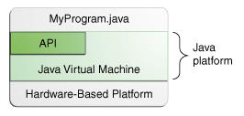

* **What Can Java Technology Can do?**
  + Development tools – Compiling, running, debugging and documenting
  + Application Programming Interface – Core functionality of the java prog lang
  + Deployment Technologies – Java web start s/w and java plug-in s/w
  + User Interface tool kits – Swing and java 2D
  + Integration Libraries – Java IDL API, JDBC API
* **How will java technology change my life?**
  + Get started quickly
  + Write less code
  + Write better code
  + Develop programs more quickly
  + Avoid platform dependencies
  + Write once run anywhere
  + Distribute software more easily